

**CAPSTONE PROJECT REPORT**

**Report 3 – Software Requirement Specification**

– Hanoi, August 2019 –

**Table of Contents**

I. Project Report 3

1. Status Report 3

2. Team Involvements 3

3. Issues/Suggestions 3

II. Software Requirement Specification 4

1. Overall Description 4

1.1 Product Overview 4

1.2 Business Rules 5

2. User Requirements 6

2.1 System Actors 6

2.2 Use Cases 6

3. Functional Requirements 8

3.1 System Functional Overview 8

3.2 <<Feature Name 1>> 10

3.3 <<Feature Name 2>> 10

4. Non-Functional Requirements 11

4.1 External Interfaces 11

4.2 Quality Attributes 12

5. Other Requirements 14

5.1 Appendix1 - Messages List 14

5.2 Appendix2 - … 14

5.3 … 14

# I. Record of Changes

| **Date** | **A* M, D** | **In charge** | **Change Description** |
| --- | --- | --- | --- |
|  |  |  |  |
|  |  |  |  |
|  |  |  |  |
|  |  |  |  |
|  |  |  |  |
|  |  |  |  |
|  |  |  |  |
|  |  |  |  |
|  |  |  |  |
|  |  |  |  |
|  |  |  |  |
|  |  |  |  |
|  |  |  |  |

*A - Added M - Modified D - Deleted

# II. Software Requirement Specification

## 1. Product Overview

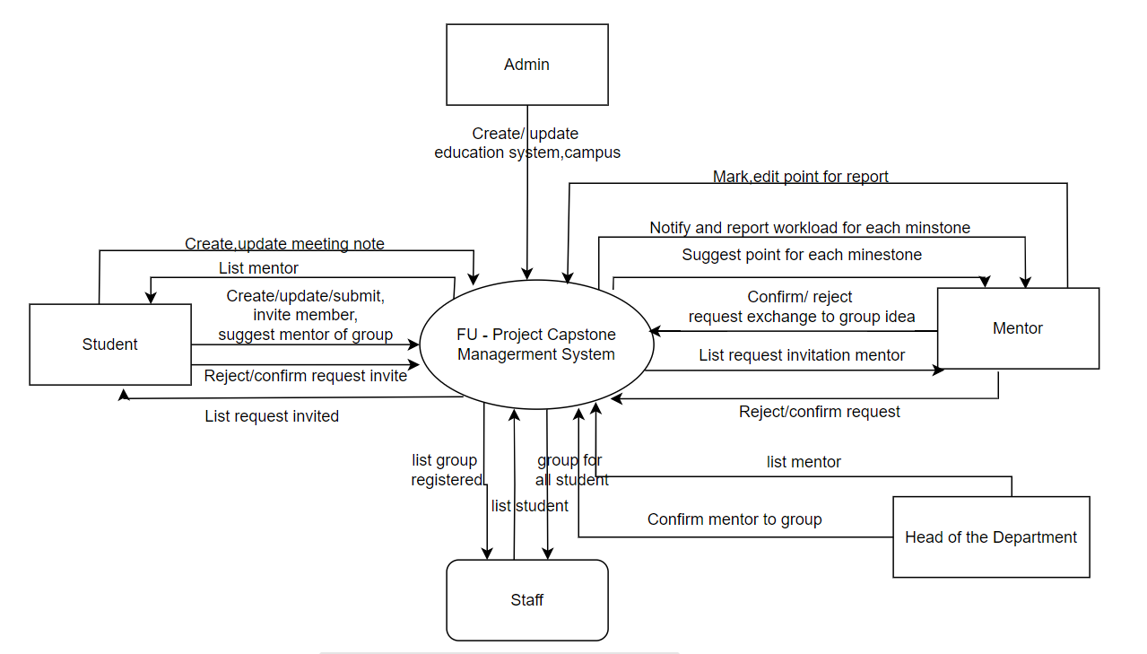

>>

## 2. User Requirements

### 2.1 Actors

| **#** | **Actor** | **Description** |
| --- | --- | --- |
| 1 | Head of the Department | A faculty member who oversees the entire capstone project program, ensuring objectives are met. |
| 2 | Student | A user who submits project proposals, collaborates with team members, and follows project guidelines. |
| 3 | Mentor | A faculty advisor who mentors students, reviews their work, and provides feedback throughout the project. |
| 4 | Staff | Is the representative of the training department who takes the list of students eligible to participate in the project and arranges them into groups |
| 5 | Admin | Administrative personnel who manage system configurations, user accounts, and support project logistics. |

### 2.2 Use Cases

#### 2.2.1 Diagram(s)

1. **Level 0 - Actors with the system**

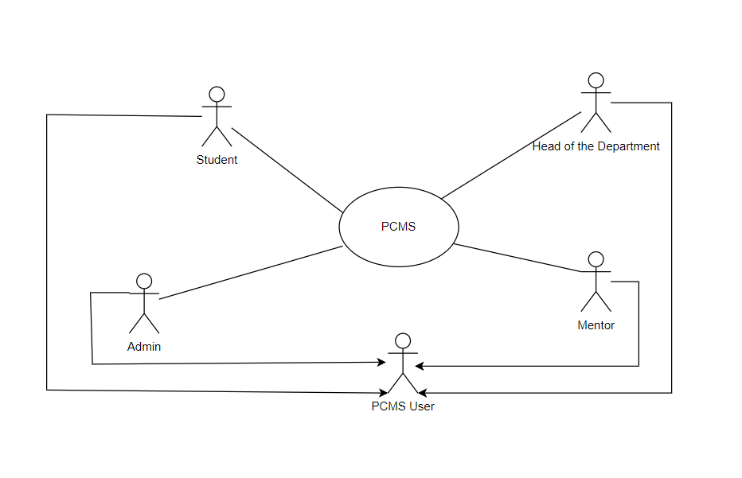

1. **Level 1 – CMCS with all modules**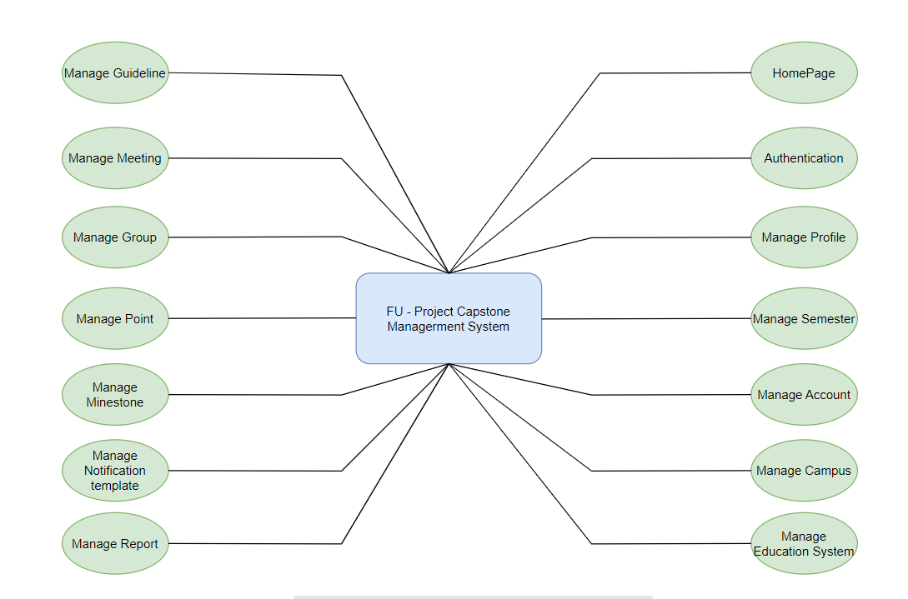
2. **Level 2 – Actors with all modules**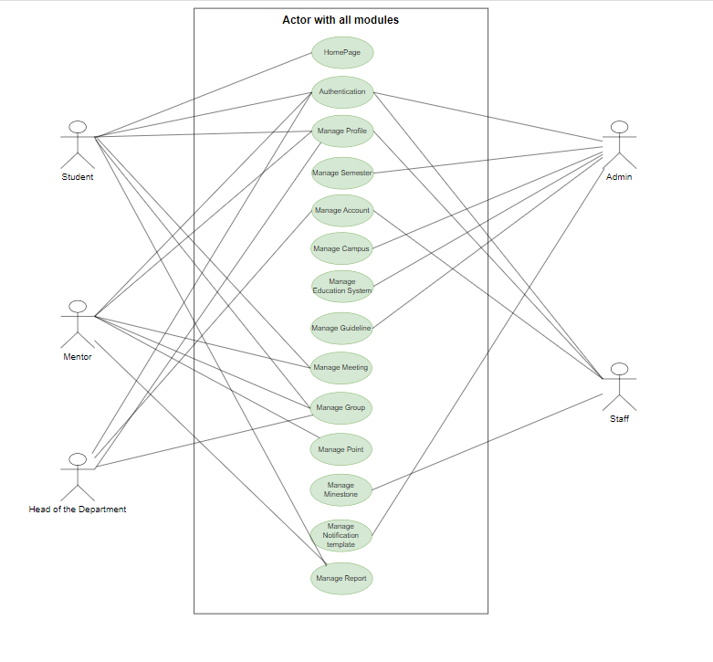
3. **Level 3 – Module with actors**

**Authentication**

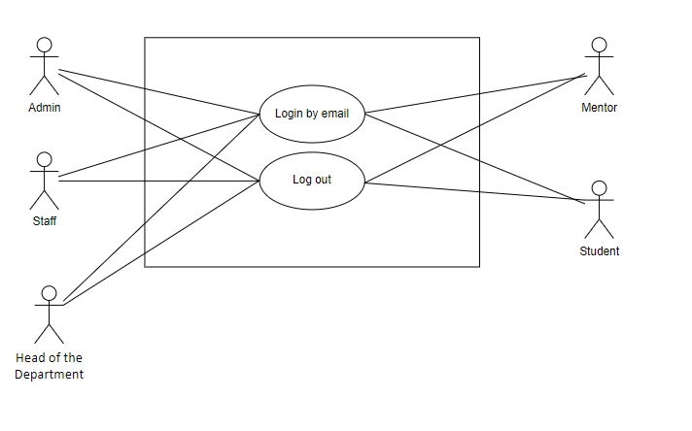

**Manage Account**

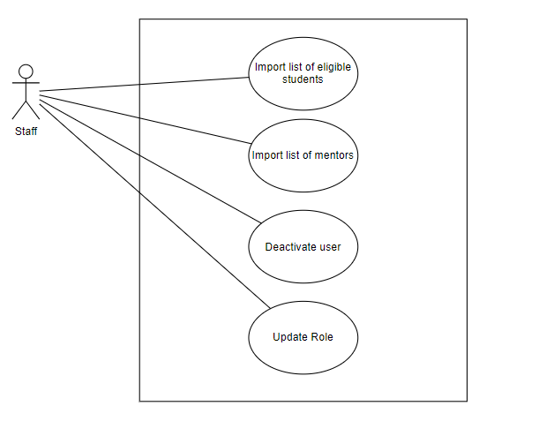

**Manage Profile**

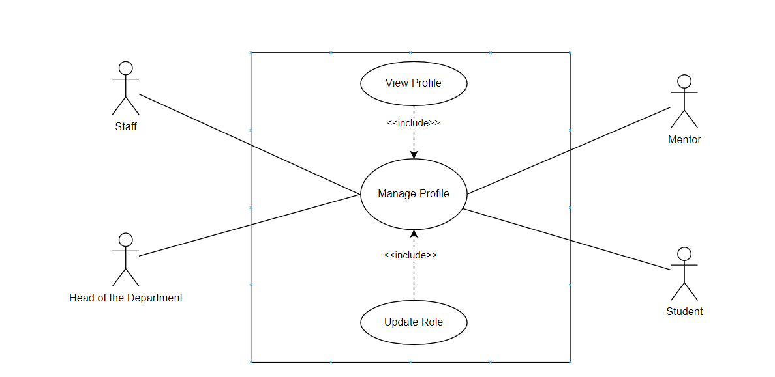

**Manage Semester**

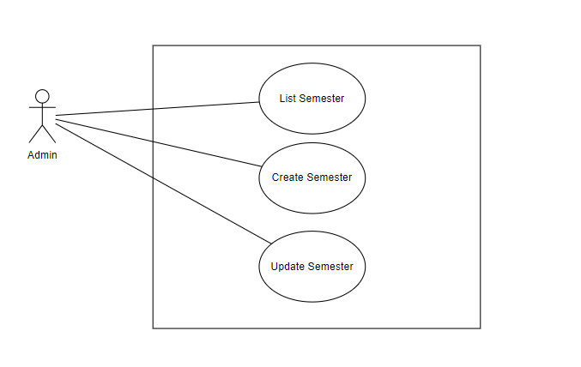

**Manage Campus**

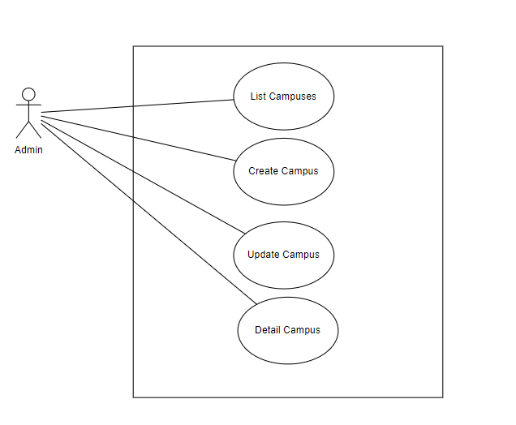

**Manage Education System**

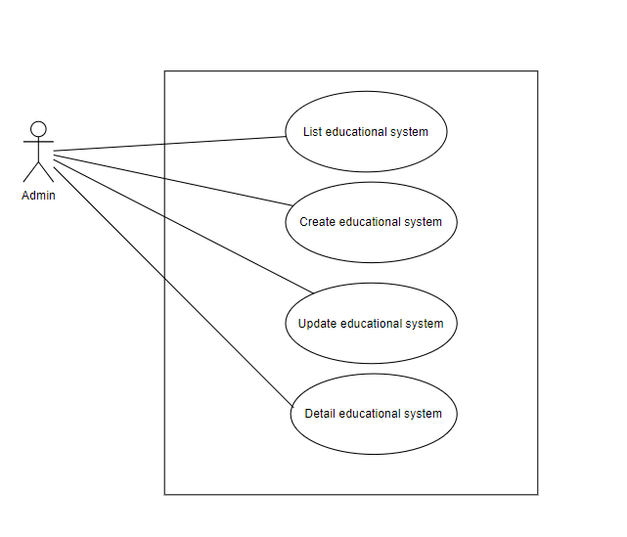

**Manage Meeting**

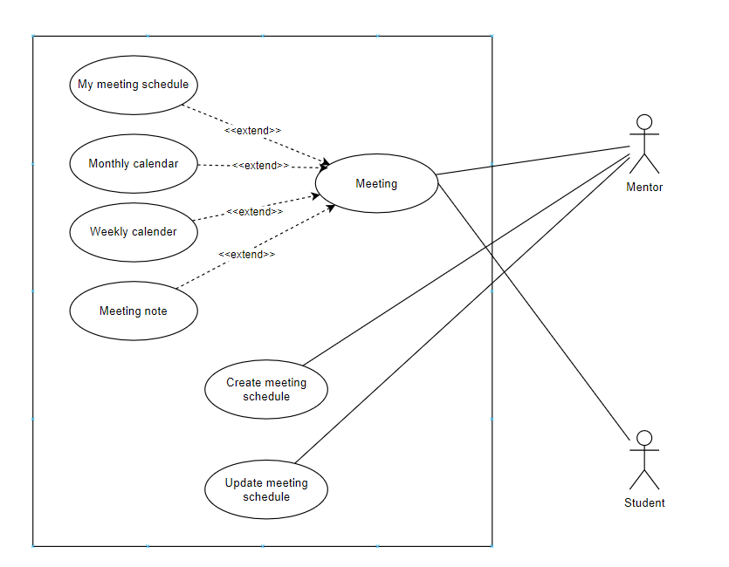

**Manage Group**

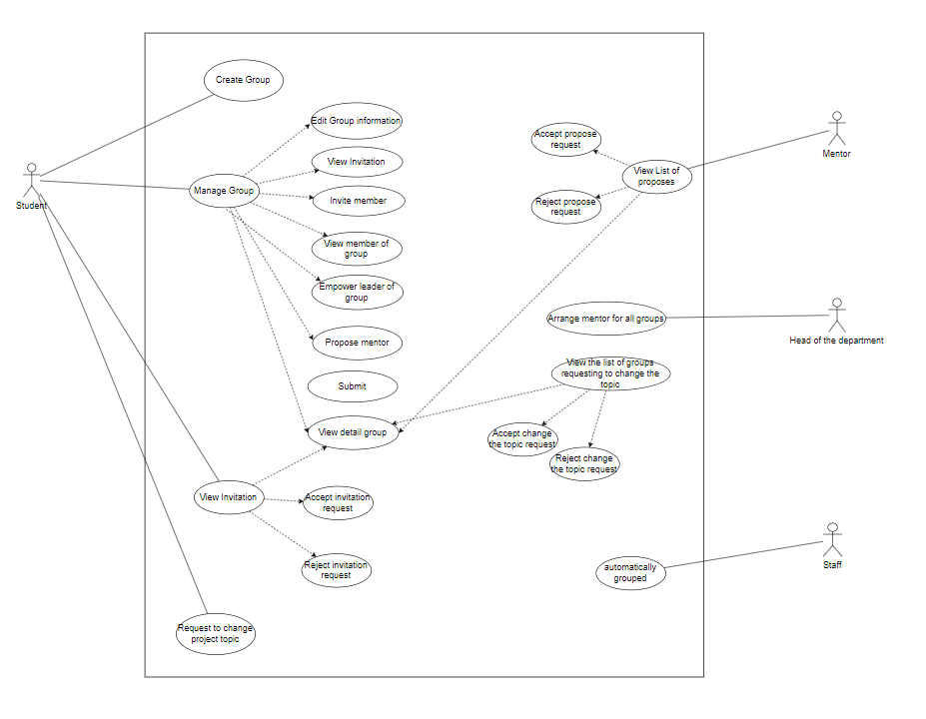

#### 2.2.2 Use Case List

| **ID** | **Use Case** | **Actors** | **Use Case Description** |
| --- | --- | --- | --- |
| 01 | Login |  | Users can login by their FPT email |
| 02 | User Profile | Student | Users can view their information |
| 03 | Update user profile | Student | Users can update some of their information |
| 04 | View list supervisor | Student | Users can view and search for selectable supervisors in the current semester |
| 05 | Supervisor Detail | Student | Users can view the information of supervisor |
| 06 | List request | Student | Users can see all invitations to the group and can accept or decline them |
| 07 | Group Detail | Student | Users can view all information about their group including topics, semesters, group members,... |
| 08 | Create idea | Student | The leader of each group can create a topic for their group including name, topic description,... |
| 09 | List Student | Staff | Users can view a list of all students in their final semester and review the conditions for students to be able to do project capstone. |
| 10 | Invite member | Student | Users can send group invitations to other students |
| 11 | Add a student to list | Staff | User can add a student to list of student |
| 12 | Add students by excel file | Staff | Users can add students to the student list using an excel file with the condition that the excel file must follow the available template |
| 13 | Download template list of student | Staff | Users can download available template so users can add student information according to the template |
| 14 | Create meeting schedule | Mentor | Users can create meeting schedules for the group they are supervising |
| 15 | Update meeting schedule | Mentor | Users can edit meeting schedules they have created |

## 3. Functional Requirements

### 3.1 System Functional Overview

#### 3.1.1 Screens Flow

1. **Student screen flow**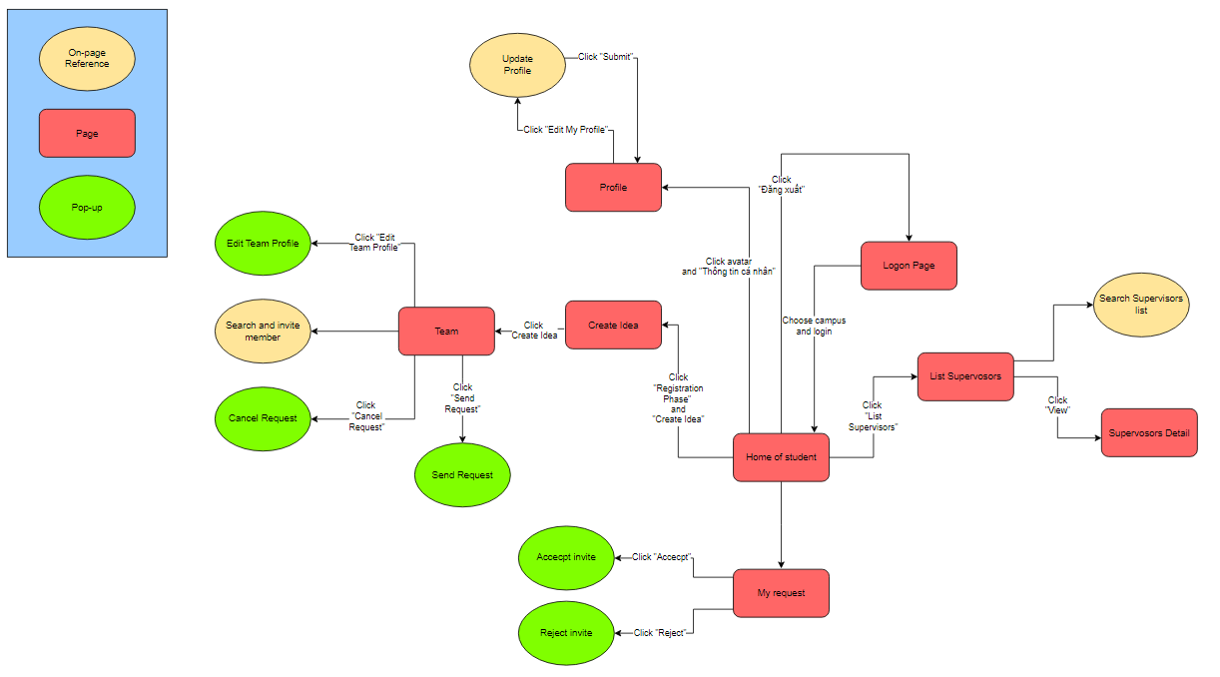
2. **Mentor screen flow**

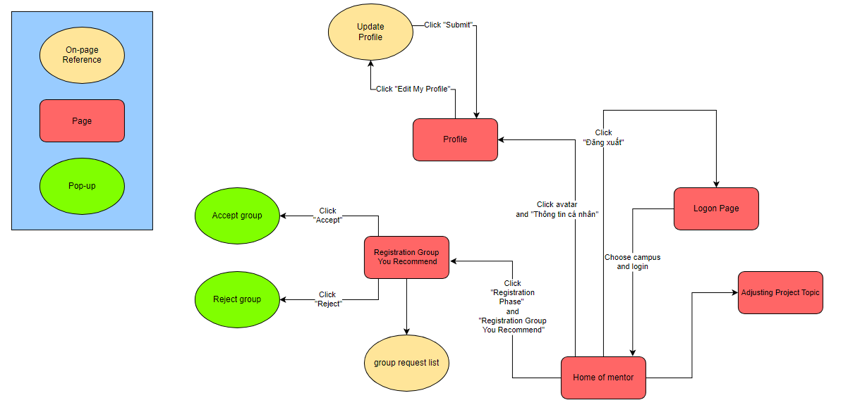

1. **Staff screen flow**

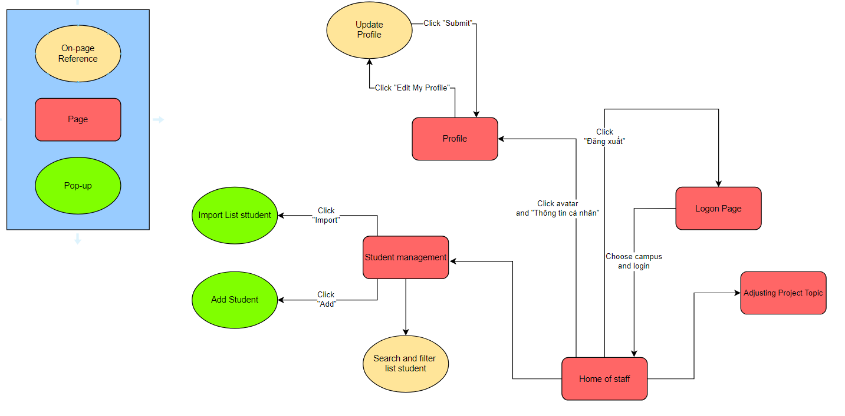

#### 3.1.2 Screen Descriptions

| **#** | **Feature** | **Screen** | **Description** |
| --- | --- | --- | --- |
| 1 | Authentication | Login by email | The screen is used for logging in to student, administrator, club manager, and admin. |
| 2 | Home Page | Home for student | This is home page for student |
| 3 | Manage profile | View profile | The screen to view profile of user |
|  |  |  |  |

#### 3.1.3 Screen Authorization

| **No** | **Feature** | **Screen** | **Student** | **Mentor** | **Staff** | **Head of the Department** | **Admin** |
| --- | --- | --- | --- | --- | --- | --- | --- |
| **1** | Authentication | Login by google | x | x | x | x | x |
| **2** | HomePage | Home of student | x |  |  |  |  |
| **3** | HomePage | Home of mentor |  | x |  | x |  |
| **4** | HomePage | Home of staff |  |  | x |  |  |
| **5** | Manage profile | View user profile | x | x | x |  |  |
| **6** | Manage profile | Update profile | x | x | x | x |  |
| **7** | Manage account | List mentor | x |  |  |  | x |
| **8** | Manage account | View profile mentor | x |  |  |  | x |
| **9** | Manage account | Import list student |  |  | x |  |  |
| **10** | Manage account | Import list mentor |  |  |  | x |  |
| **11** | Manage account | Activate/ deactivate account |  |  | x |  | x |
| **12** | Manage group | View list group |  |  | x |  |  |
| **13** | Manage group | View details group | x | x |  |  |  |
| **14** | Manage group | View list group invited | x |  |  |  |  |
| **15** | Manage group | Change leader group | x |  |  |  |  |
| **16** | Manage group | View list group suggest to mentor |  | x |  |  |  |
| **17** | Manage group | Accept invite to member group | x |  |  |  |  |
| **18** | Manage group | Accept invite to mentor group |  | x |  |  |  |
| **19** | Manage group | Update group information | x |  |  |  |  |
| **20** | Manage group | Submit group to finalise ideas | x |  |  |  |  |
| **21** | Manage group | Create a group for no group students |  |  | x |  |  |
| **22** | Manage group | Mentoring for all groups |  |  |  | x |  |
| **23** | Settings | Setting google drive |  |  |  |  | x |
| **24** | Settings | Setting email |  |  |  |  | x |
| **25** | Manage campus | List campus |  |  |  |  | x |
| **26** | Manage campus | View campus |  |  |  |  | x |
| **27** | Manage campus | Update campus |  |  |  |  | x |
| **28** | Manage campus | Create new campus |  |  |  |  | x |
| **29** | Manage education system | List education system |  |  |  |  | x |
| **30** | Manage education system | View education system |  |  |  |  | x |
| **31** | Manage education system | Update education system |  |  |  |  | x |
| **32** | Manage education system | Create new education system |  |  |  |  | x |
| **33** | Manage guideline | List guideline |  |  |  |  | x |
| **34** | Manage guideline | Create guideline |  |  |  |  | x |
| **35** | Manage guideline | View details guideline |  |  |  |  | x |
| **74** | Manage guideline | Update guideline |  |  |  |  | x |
| **81** | Manage meeting | My meeting | x | x |  |  |  |
| **82** | Manage meeting | Meeting schedule for the week | x | x |  |  |  |
| **83** | Manage meeting | Meeting schedule for the month | x | x |  |  |  |
| **84** | Manage meeting | Create meeting note | x | x |  |  |  |
| **85** | Manage meeting | Update meeting note | x | x |  |  |  |

### 3.2 <<Feature Name 1>>

#### 3.2.1 <<Function Name 1>>

*[A function can be a screen or a non-screen function (listed in the part 3.1.5 above). In this part, you need to provide the details on the related function, focus on mentioning below information*

* *Function trigger: how this function is triggered (navigation path, a timing frequency, etc.*
* *Function description: actors/roles, purpose, interface, data processing, etc.*
* *Screen layout: mock-up prototype of the screen, sample below is for Manage Products screen*

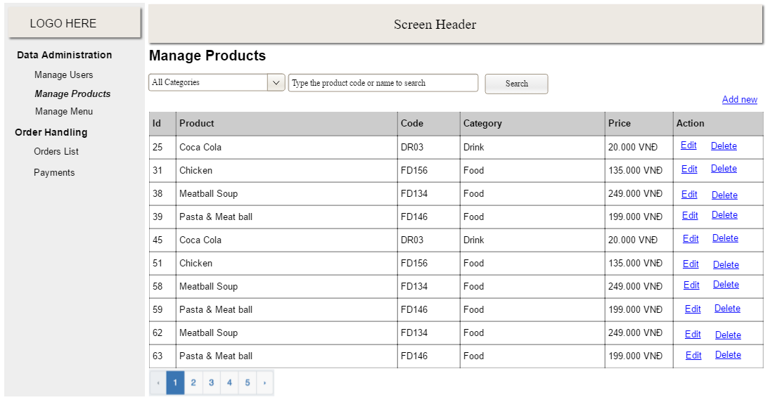

* *Function Details: provide explanation for the data, validation, business rules, functionalities (for both normal cases and abnormal cases), etc. of the function so that the reader can image how it work.*

*]*

#### 3.2.2 <<Function Name 2>>

…

### 3.3 <<Feature Name 2>>

…

### 4. Non-Functional Requirements

#### 4.1 External Interfaces

* **User Interface**: Giao diện người dùng thân thiện, dễ sử dụng, hỗ trợ cả desktop và mobile.
* **API**: Hệ thống sẽ cung cấp các API để tương tác với frontend và các hệ thống khác.

#### 4.2 Quality Attributes

* **Hiệu Năng**: Hệ thống phải đáp ứng được số lượng người dùng đồng thời lớn mà không bị chậm trễ.
* **Bảo Mật**: Hệ thống phải bảo đảm an toàn dữ liệu người dùng và hạn chế truy cập trái phép.
* **Khả Năng Bảo Trì**: Hệ thống phải dễ dàng bảo trì và nâng cấp trong tương lai.
* **Khả Năng Mở Rộng**: Hệ thống phải có khả năng mở rộng để phục vụ số lượng người dùng ngày càng tăng.

### 5. Other Requirements

#### 5.1 Appendix 1 - Messages List

* **Thông báo lỗi**: Cung cấp danh sách các thông báo lỗi và cách xử lý.
* **Thông báo hệ thống**: Cung cấp danh sách các thông báo từ hệ thống tới người dùng.

#### 5.2 Appendix 2 - Glossary

* **Định nghĩa thuật ngữ**: Cung cấp định nghĩa các thuật ngữ chuyên ngành sử dụng trong dự án.

#### 5.3 Appendix 3 - Diagrams

* **Sơ đồ kiến trúc**: Cung cấp sơ đồ kiến trúc hệ thống.
* **Sơ đồ ERD**: Cung cấp sơ đồ ERD mô tả cơ sở dữ liệu.